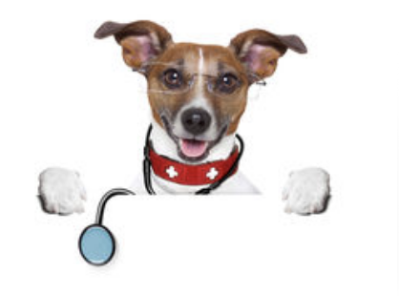

BRAND HEALTH
CHECK

BRAND HEALTH CHECK

It’s a good idea to refresh a brand every 5-10 years or so but not for the sake of it. The tweaks can be really subtle to allow for any changes in the direction or scope of your business or occasionally a total re-brand is required.

Your logo may have been created before the social media boom so the format doesn’t really work due to the shape or fonts.

Ovy Design suggest you need to look at your brand objectively and be brutally honest when considering the following 6 aspects:

1. Does your brand still reflect your products or services?

For example, your business may have taken a very different path than you had anticipated so being called ‘Just Juice’ no longer reflects the yoghurts, brunch bars and snacks you sell.

2. Is the font completely legible?

Don’t fall into the trap of choosing a fashionable font or one you like the look of if it’s really not right for your market or audience. For example, if your product or service is aimed at the elderly you would want to ensure the font was strong and clear.

3. Would a new customer know what you are offering if they saw your logo for the 1st time?

You only get a split second to make a lasting impression so your logo needs to tell your story either through the words (York Bread Shop) or through the image and name together or in some cases the image is essentially accompanied by a strapline as the name is so obscure and/or quirky (Brown Cow’s - Artisan Breads).

4. Does it work on social media?

For example, very wide landscape logo’s would reduce so small in order to fit your profile that they cannot be read. Square or round shapes work best. These days companies need to have a version of their logo specifically for social media.

5. Do the colours suit your market?

For example you wouldn’t really expect an organic greengrocer to have a red colour scheme when green and brown would instantly convey images of fresh, healthy, plants and soil.

6. Is it professional?

Did you commission a professional graphic designer to create your logo? Some new businesses cobble a logo together using clip art and Word and it shows! A cheap and unprofessional logo suggests the same about your products or services in the eyes of your potential customers. Some online printers also offer a ‘logo’ and template as part of their print services, but this is the wrong path to take. You’ve spent all this time, effort and money building your brand only to discover down the line that you don’t actually ‘own’ your logo and that it is, in fact a shared template that 100’s of other businesses are using, possibly your competitors. How embarrassing to turn up at a networking event to discover someone else has the same business card?

If you’ve answered NO to any of these questions it’s time for a re-brand. Ovy Design can work with you to create a logo that truly reflects your business right now and will take you forward to grow your business.

Visit the Logo’s & Branding section of our website to see how the process works and to browse through the gallery of other logo’s we’ve created. It’s very visual and not at all boring – we promise! https://www.ovydesign.co.uk/logos-branding

Contact us now, we’d love to hear from you: 01949 877099

